# Purpose / Goal

DPAR stands for: Design, Process and Assembly Review.

The purpose is to get commitment from supplier and Camso cross functional teams regarding feasibility in manufacturability, quality, packaging definition and timing in order to minimize any risk and cost avoidance upfront.

This process shall be conducted when required from Camso or the supplier for:

* Approval of new parts or assembly or material;
* Existing parts from a new supplier;
* Existing parts from existing supplier where there has been a substantive change in the supplier's manufacturing process, tooling, and/or location;
* Any change that impacts the fit, function or appearance of the part.

The DPAR template file contains the detailed instructions on how to perform the review.

The goal is to ensure that both parties have a clear understanding of Camso’s expectations / requirements and that the parts / product / assembly:

* Meet the functional and aesthetic needs;
* Are designed for the proper climate and working conditions;
* Are designed for the lowest operating cost and are consistent with the lifecycle expected;
* Meet the manufacturability of the equipment used to produce them:
* Meet the budgeted cost, and are produced on time;
* To obtain a design freeze, ready for ordering P3 or production parts.

# Scope

The process covered here addresses all Camso outsourced parts / systems / products / raw material. It involves all Camso Global Procurement and BUs / MDI in the main following functions: Product Design, Sales, PMO, Quality, Manufacturing, Procurement and Product Support. For the Mixing division, many projects are accomplished in collaboration with the BUs which use the DPAR process.

|  |  |
| --- | --- |
| Process owner: | 1. VP Procurement   R- Procurement  S- Supplier Quality Manager  S- Engineering |
| Author: | GP Supplier Quality Manager |

Table of contents

1- Purpose / Goal 1

2- Scope 1

3- Process information 2

4- Process mapping: 3

5- Process Description 3

6- Group Roles Description 5

7- Revision History 5

# Process information

|  |  |  |  |
| --- | --- | --- | --- |
| **Supplier** | **Input** | **Output** | **Customer** |
| **Camso:**   * Strategic Buyers * Procurement Mgr * Project Buyers * Project Mgr * Engineering * Quality (Plant) * Supplier Quality   **Suppliers:**   * Main contacts | * Internal technical review * Quality review (PPAP requirements, Inspection plan, Lessons Learned) * Specifications * Validation plan DVP&R * Project time line (P3/PPAP) * Preliminary PPAP requirement (initial control plan, process flow) | * DPAR completed: All open issues are resolved before P3 submission and mass production orders * Supplier agreement * Revised documents and specs * Design freeze * Manufacturability process established * Measurement agreement * PPAP submission requirement | The main BUs/MDI functions:   * Product design * Product line * PMO * Quality * Manufacturing * Procurement * Product support * Quality * Supplier(s) |

|  |  |
| --- | --- |
| **Associated tool(s)** | **Associated document(s)** |
| **NOTE:** The tools are located in the [GP Toolbox](https://intranet.camso.co/teams/GP/Toolbox%20Test/Forms/Approved%20Tools.aspx) (GP Sharepoint site)   * + DPAR template   + DPAR example | * DPAR training document * DPAR assessment questionnaire * APQP-PPAP training |

# Process mapping:

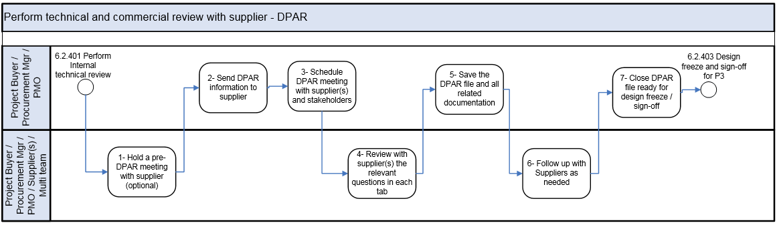

# Process Description

|  |  |  |  |  |
| --- | --- | --- | --- | --- |
| ***No*** | ***Task / Process name*** | ***Roles/Responsible*** | ***Document / Tool / Output*** | ***Task / Process description*** |
| **1** | Hold a pre-DPAR meeting with supplier (optional) | R- Project Buyers  R- Procurement Mgrs  R- PMO | DPAR Template & Process | Note: At this point, the process 6.2.401 Perform Internal Technical Review should already have been completed.   * Exchange existing drawings and technical information with the supplier. * Complete the preliminary portion of the DPAR form with suppliers and team to validate if supplier is capable |
| **2** | Send DPAR information to supplier | R- Project Buyers  R- Procurement Mgrs  R- PMO | * Drawings * DPAR template | * Send the DPAR technical information to supplier prior to the supplier meeting * Send agenda to the Suppliers. |
| **3** | Schedule DPAR meeting with supplier(s) and stakeholders | R- Project Buyers  R- Procurement Mgrs  R- PMO | Meeting scheduled | * Schedule a DPAR meeting with Supplier(s) and all key stakeholders. * Plan meeting date and invite stakeholders. |
| **4** | Review with supplier(s) the relevant questions in each tab | R/A- Project Buyers  R- Procurement Mgrs  R- PMO  S- Engineering  S- SPQD (or Plant Quality)  S- Logistic/Planner  S- Supplier(s) | * DPAR template * DPAR training * PPAP review checklist * PPAP training | * Review with the Supplier(s) the relevant questions in each tab. **(see example below)** * **Please refer to the DPAR training material in order to see the instruction for each tab. This training material should be useful for the suppliers as well as for Camso employees.**   **Note: At the end of the DPAR meeting, you can validate:**   * Everyone’s comprehension and responsibility. * Ask everyone’s input regarding this DPAR such as:   + Any missing stakeholders   + Any missing items   + Others |
| **5** | Save the DPAR file and all related documentation | R- Project Buyers  R- Procurement Mgrs  R- PMO | * DPAR template * Drawing | * The DPAR file and all related documentation shall be saved in the appropriate SharePoint site or network location (BU/DIV/Global). |
| **6** | Follow up with Suppliers as needed | R/A- Project Buyers  R- Procurement Mgrs  R- PMO  S- Supplier(s)  S- Multi team | * DPAR template | * Update regularly the DPAR file. * Depending on the specific BU/MDI organization rules, you may ask your specific stakeholders to update their part in the DPAR file. * Supplier and CAMSO cross functional teams sign off DPAR in the tab named Coversheet. |
| **7** | Close DPAR file ready for design freeze / sign-off | R- Project Buyers  R- Procurement Mgrs  R- PMO | * DPAR template * Drawing | * Once the DPAR is completed, the product is now ready for the next step which is design freeze / sign-off. * Save the completed DPAR documentation and upload in the relevant Project in PPM. |

# Group Roles Description

|  |  |
| --- | --- |
| ***Group Role*** | ***Description*** |
| Multi team | Product Design  Product Line  Sales  PMO / Engineering  Quality  Manufacturing  Procurement  Product support  Plant Dir |

# Revision History

|  |  |  |  |
| --- | --- | --- | --- |
| Revision # | Date | Revision summary | Revised by |
| Created | 2017-05-04 |  | Alain Brault |
| Update | 2019-11-25 | Purpose: wording change (lowest cost to lowest operating cost)  Process description: separate SPQD & Plant Quality, remove example of DPAR tab (Lessons Learnt)  Tools: add a DPAR example, update training material, procurement site, Camso Li | Nordin Mimouni |